

ASSIGNMENT 3 - FORTRAN
COURSE CL5P252
NAME OF THE COURSE – NUMERICAL MODELLING AND DIAGNOSTICS LAB

NAME – AAROKSH CHAUHAN
PROFESSOR NAME- DR. SANDEEP K.K
DATE OF LABORATORY – 23 MARCH 2026
DATE OF SUBMISSION – 28 MARCH 2026
FORTRAN PROGRAMMING

Q.1) Write a Fortran program to estimate the Mean, Standard Deviation.

Solution – For finding out the mean of one dimensional array in fortran , we have used the following code :
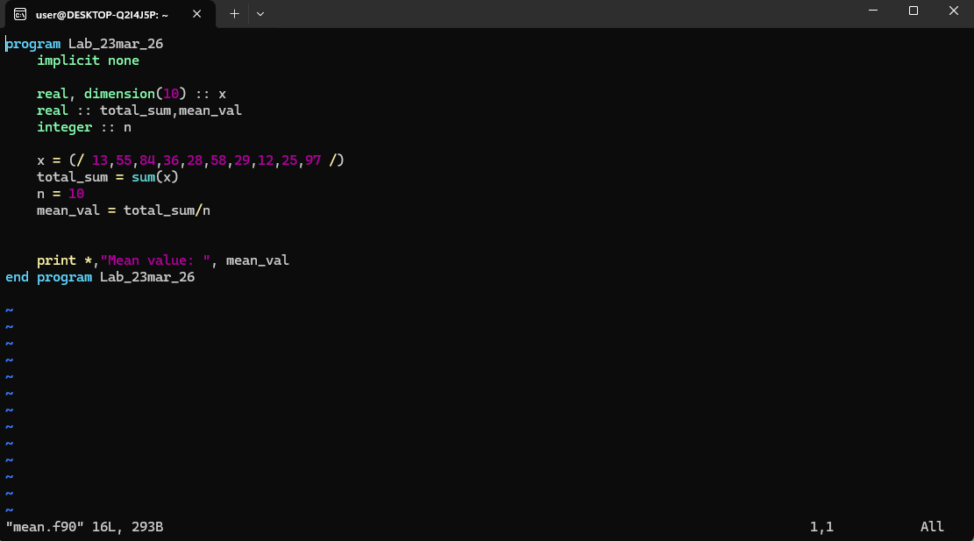

In this code , we have took into consideration an one dimensional array x = (13,55,84,36,28,58,29,12,25,97) . So basically we have firstly took the sum of these values , then divided it with the length of the array n (here, 10) . “print *,
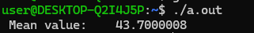
helps us in printing out the mean values which is coming out to be

And , for finding out the standard deviation , we have used the code :

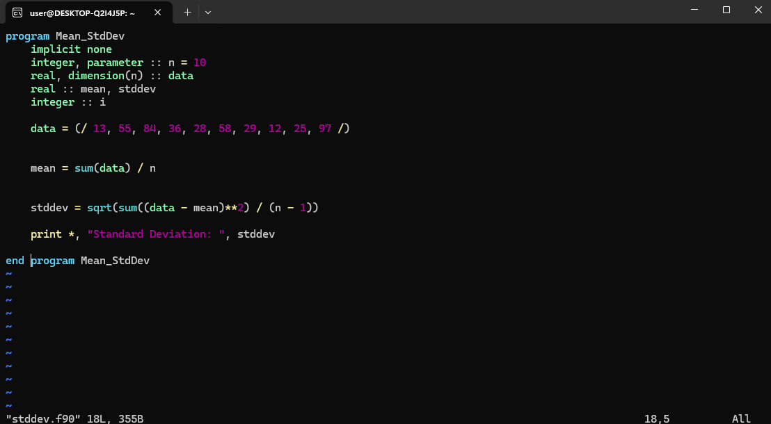

As we can see in this code , we have assumed another one dimensional array named data = (13,55,84,36,28,58,29,12,25,97) . To find its standard deviation , we have simply calculated its mean using the formula [sum of data / length of data], then doing the difference between the actual data and its mean values , summing up these values and taking square of it .
At last , divide the obtained number with the (length of data – 1) , here length of data is denoted by n . Hence , the obtained result is :
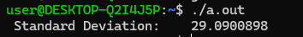

Q.2 ) Write a Fortran program to estimate the Correlation coefficient between two one-dimensional arrays.

Solution – To compute Correlation coefficient between two one dimensional arrays , we have used the following code for determining the correlation coefficient :

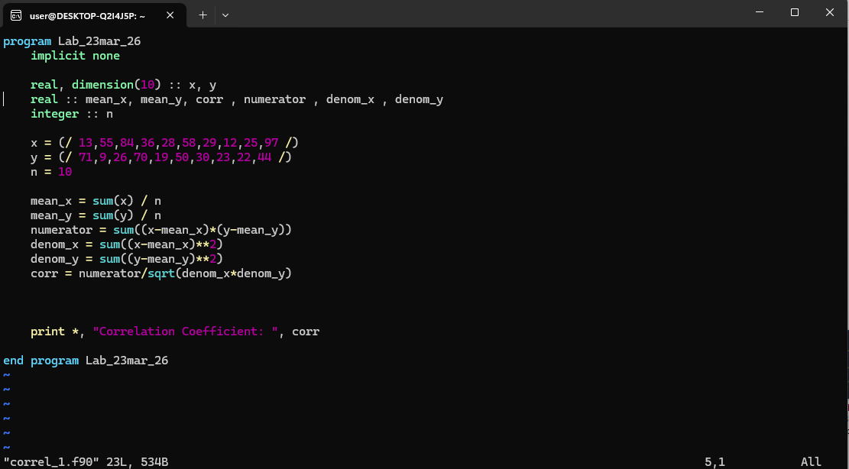

As we can see in this code , we have defined two arrays ; x = (13,55,84,36,58,29,12,25,97) and y = (71,9,26,70,19,50,30,23,22,44). So basically , firstly we have found out the mean of both x and y ( mean _x and mean_y)
- Next , we have determined the sum of ( y- mean_y) and (x-mean_x) , which will be the numerator
- Then , we have determined the sum of the square of ( y – mean_y) and sum of the square of (x – mean_x) ; and ,multiplied these values
- On multiplying these the above obtained values gives us our denominator
- At last , we will divide the denominator by numerator to obtain the correlation coefficient , which is coming out to be :

Q.3) Write a Fortran program to estimate the RMSE between two one dimensional arrays, one representing the observation and other from simulation.

Solution – For computing the RMSE (Root mean square error) , we have used the following code :

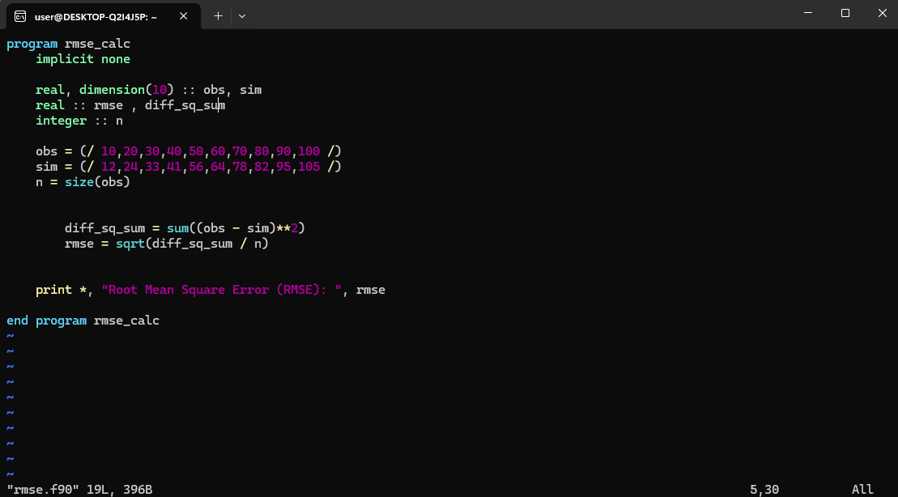

As we can see that in this , we have two arrays , one representing the observed values , obs = ( 10,20,30,40,50,60,70,80,90,100 ) , and another one representing the simulation values , sim = ( 12,24,33,41,56,64,78,82,95,105 )

- Firstly , we will determine the size of arrays , since both have same size here , we can assume the size of any one array as n
- Next , we will sum up the squared values obtained from the observation values – simulation values .
- Also , we will the divide it with the size of array n , the take out the square root of it .
The obtained value is the RMSE , which is coming out to be :
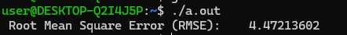

Q.4) Write a Fortran program to sort a one-dimensional array. Modify the program to read input data from a text/ascii file and write to a text/ascii file.

Solution – For performing this operation in Fortran , we must be using ‘.txt’ file to perform our operations on ; instead of f.90 file .So , we will create and save ‘input.txt’ file to take input values from ; and ‘. Also the flow of the code should be like as follows :
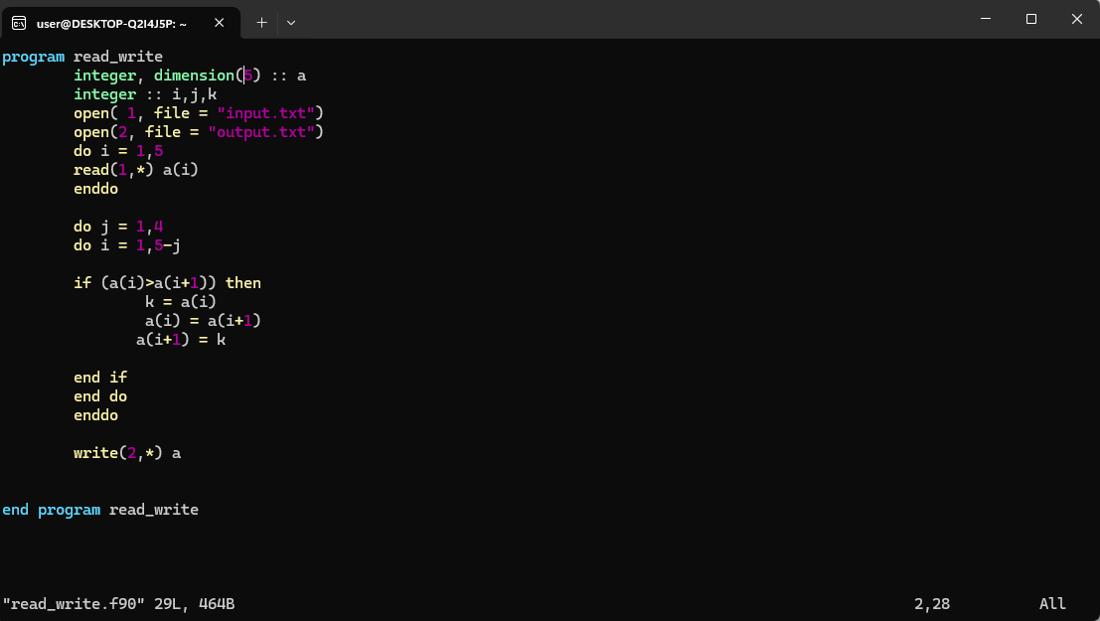

- So firstly , we will specify the dimension of the array a (here , 5) and integers i,j,k
- Next , opening the file ‘input.txt’ and assigning it a number as 1 ; similarly opening the file ‘output.txt’ and assigning it number as 2
- Line no 6 to 8 makes sure to read the file 5 times
- Then ,do j = 1,4 makes sure to repeat the iterating process 4 times and do i =1,5-j makes sure the range of index number in which the sorting will happen .
- ‘If’ loop is the loop which actually sorts the numbers given in the ‘input.txt.’ file .
- “Write(2,*) a “ writes these values on the ‘output.txt’ file

So , initially the input.txt file contains value randomly ordered
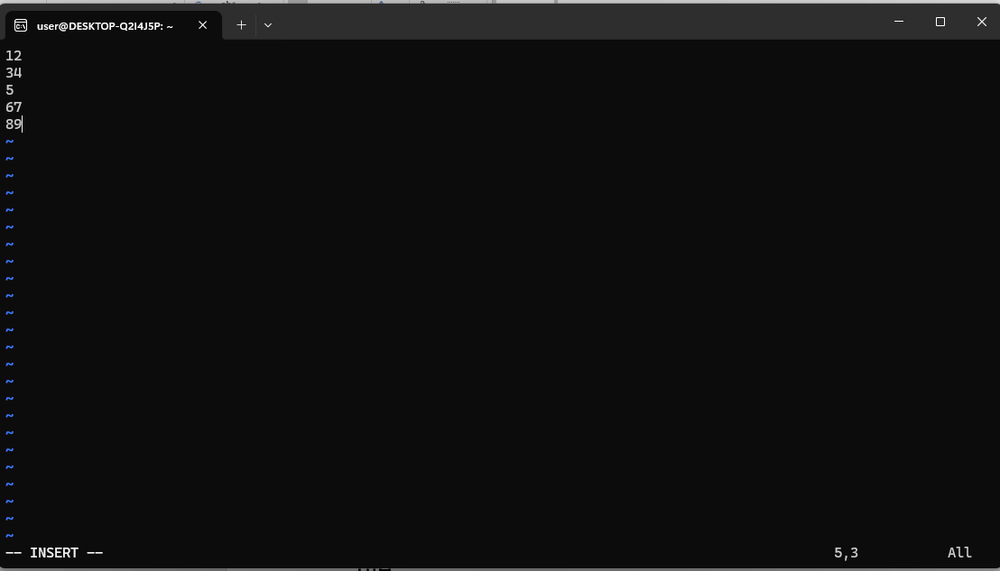

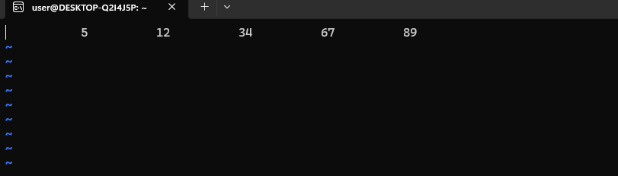
And after running the sort program , the output is :

Q.5) Write a Fortran program to find the maximum and minimum of a one-dimensional array.

Solution – To find maximum and minimum of an array , we will use the following code :
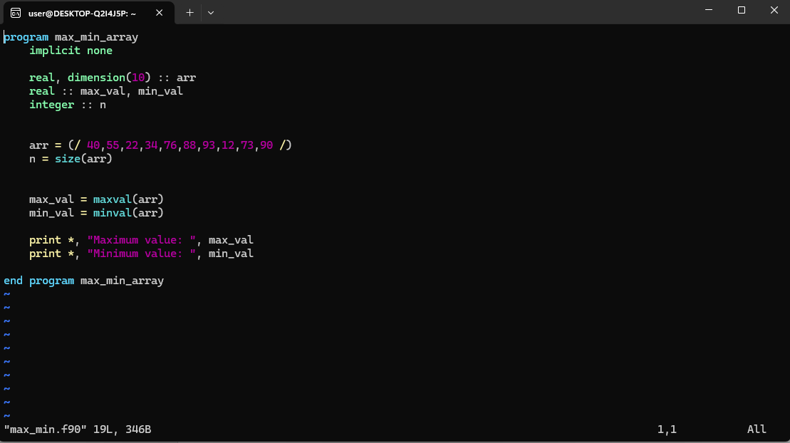

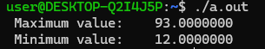
As for finding the max and min of the array , we will simply define an array , here it is arr = (40,55,22,34,76,88,93,12,73,90 ) . To find maximum of it , we will use “maxval(arr)” ; and to find minimum value , we will use “minval(arr)” . And then use the print function to obtain these values

PYTHON PROGRAMMING

Q.1) Read the netcdf file provided, note down the names of all the variables, the corresponding long_name, and units. Also, note down the dimension names and sizes of the variables.

Solution – The net cdf file provided has the following variables and dimensions :

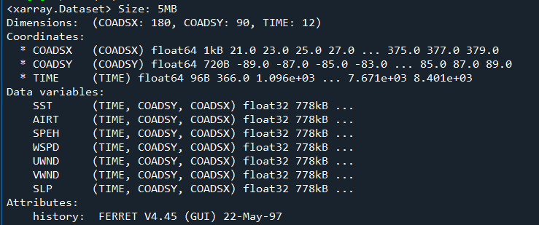
DATA VARIABLES
- COADSX – Longitude values , ranging from 21°E to 379°E , having 180 steps with a resolution of 2°
- COADSY- Latitude values , ranging from -89°N to 89°N , having 90 steps with a resolution of 2°
- TIME – Time values , hourly data with the resolution not clearly visible

DIMENSIONS

- SST - SEA SURFACE TEMPERATURE (in °C)
- AIRT - AIR TEMPERATURE (in °C)
- SPEH - SPECIFIC HUMIDITY(in g/kg)
- WSPD- WIND SPEED (in m/s)
- UWND - ZONAL WIND ( in m/s)
- VWND- MERIDIONAL WIND (in m/s)
- SLP - SEA LEVEL PRESSURE ( in mb)

Q2)Estimate the saturation vapor pressure, using the sea surface temperature provided in the netcdf file.

Solution –
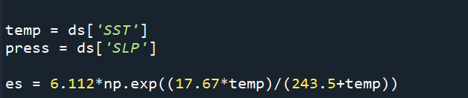

Where , temp is the SST values and Es is the saturation vapour pressure .

Q3) Estimate the saturation specific humidity. Use the sea level pressure provided in the netcdf file and the saturation vapor pressure from above.

Solution –
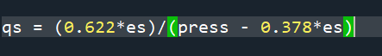

Where , qs represents the specific humidity , es represents the saturation vapour pressure ,and press represents pressure .

